|  | **MATHEMATICS METHODS**  **MATHEMATICS YEAR 12, UNIT 3**  **TASK 2: TEST 1**  **Differentiation and Antidifferentiation**  **Weighting: 8%** |  |
| --- | --- | --- |

**SECTION A: Calculator Free Section**

**TIME: 28 min**

**MARKS: 36**

**Student Name: _ _**

**TO BE PROVIDED BY THE STUDENT**

Standard Items: Pens, pencils, eraser, ruler.

**INSTRUCTIONS TO STUDENTS:**

You are required to attempt ALL questions,

Write answers in the spaces provided beneath each question.

Marks are shown with the questions.

**Show all working** clearly, in sufficient detail to allow your answers to be checked readily and for marks to be answered for reasoning. Incorrect answers given without supporting reasoning cannot be allocated any marks. For any question or part question worth more than two marks, valid working or justification is required to receive full marks.

It is recommended that students **do not use a pencil,** except in diagrams.

1. [ 2,2,3,3 = 10 marks]

Differentiate each of the following with respect to *x*. Do not simplify.

* 1. 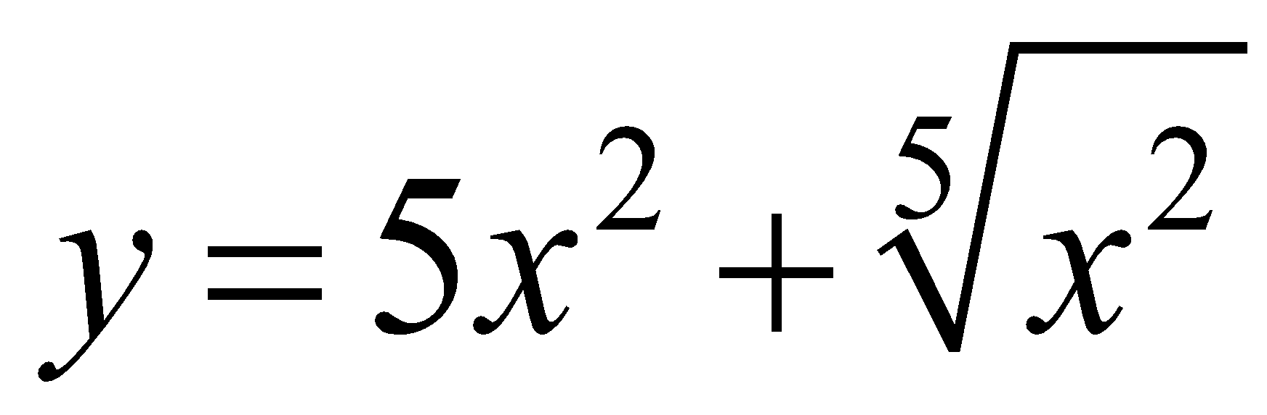 [2]
  2. 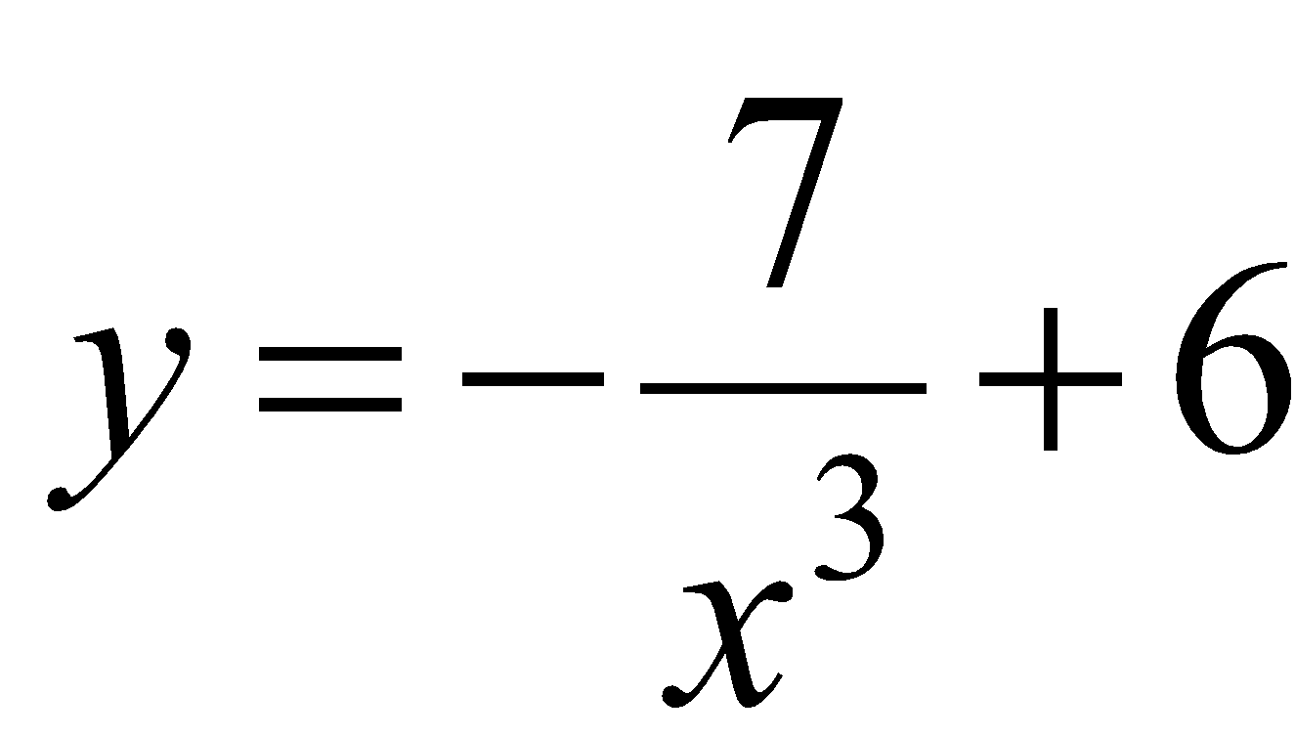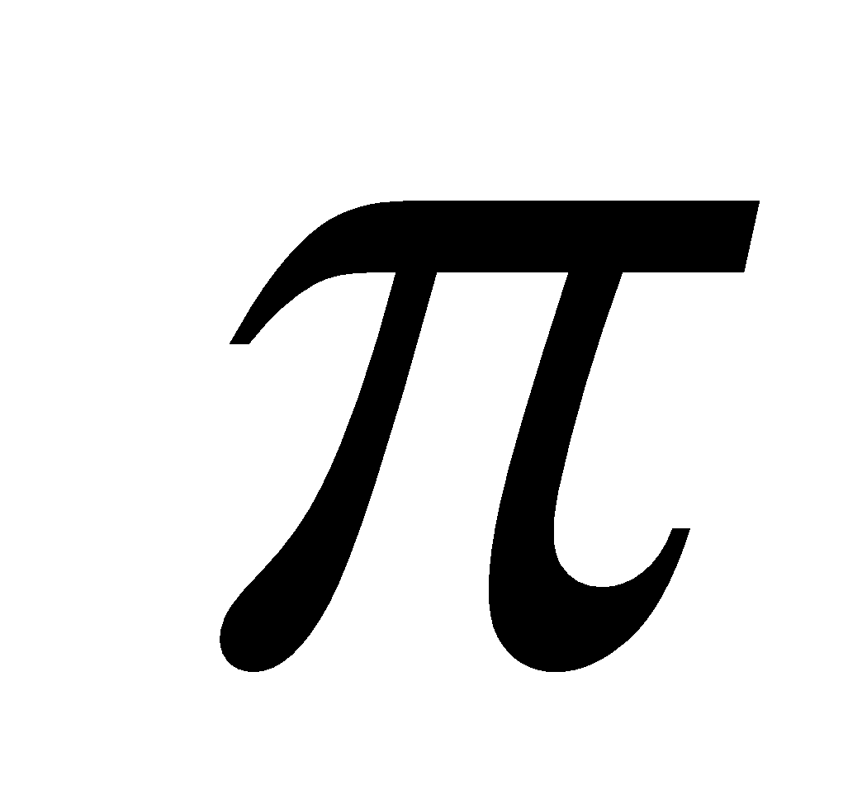 [2]
  3. 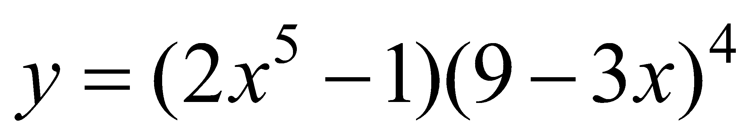 [3]
  4. 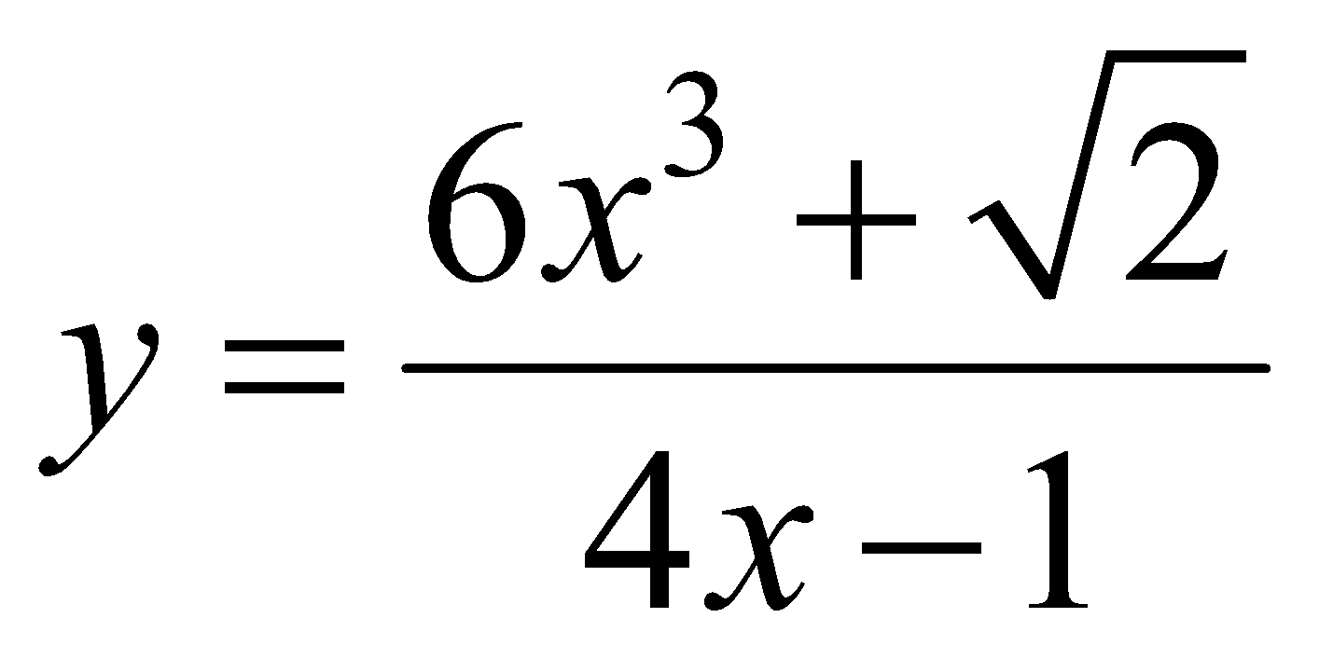 [3]

1. [4 marks ]

If 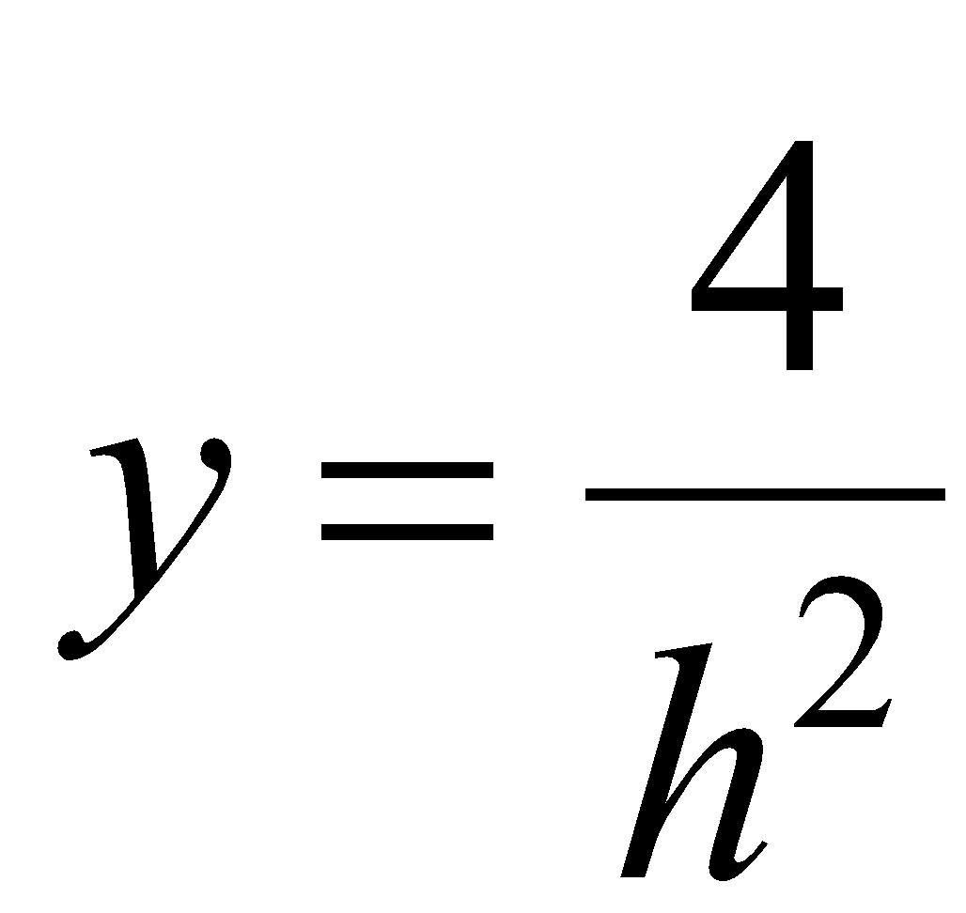 and 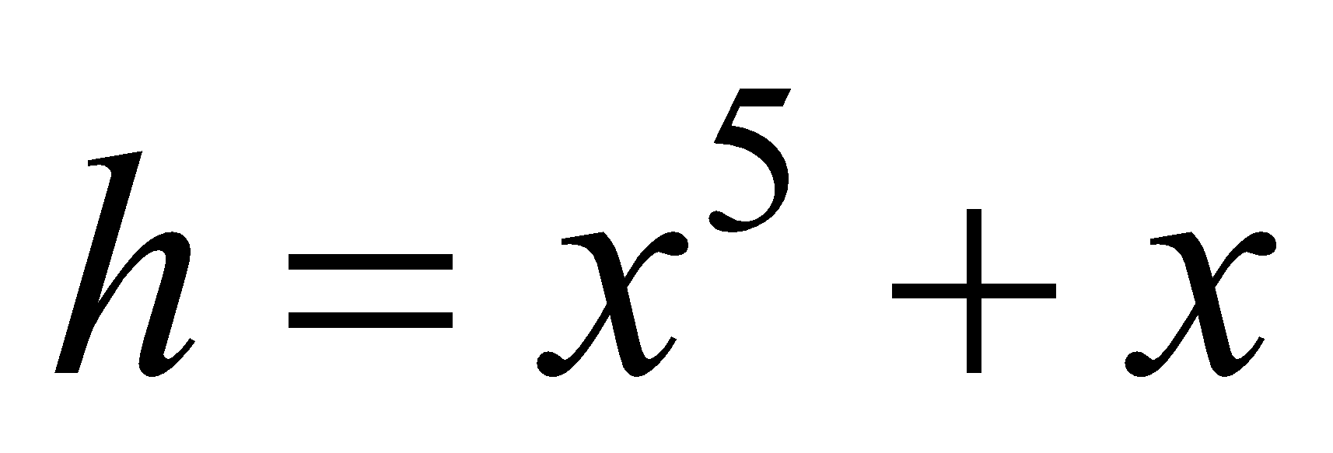, demonstrate the use of the chain rule to determine 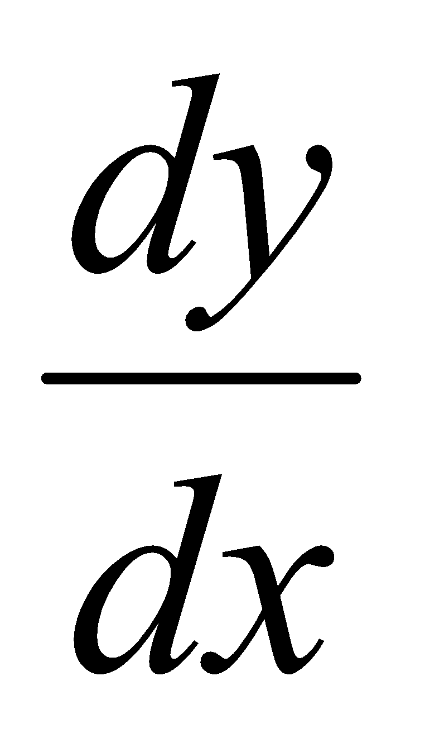.

3. [ 3, 3, 3 = 9 marks ]

(a) Determine 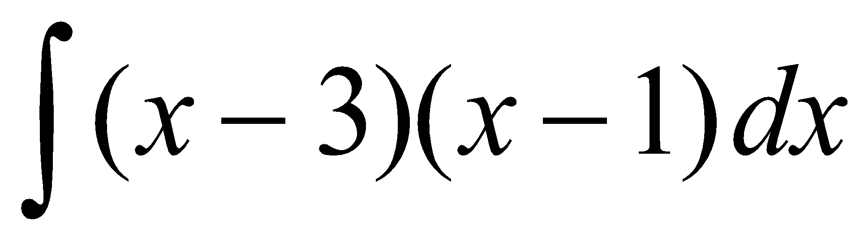

(b) Determine 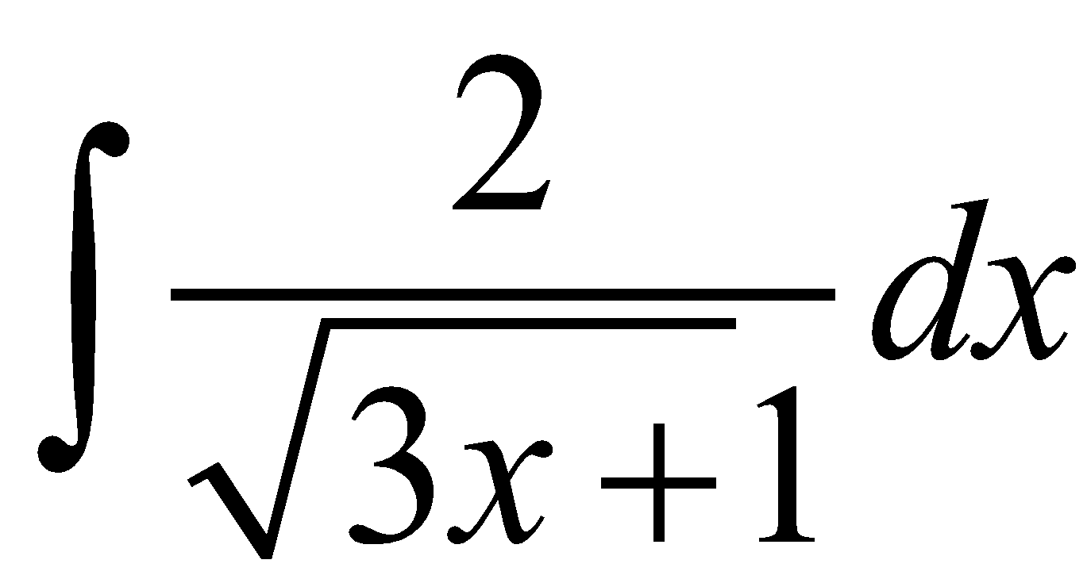

(c) Determine *dx*

4. [ 3 marks]

Below are six graphs. 3 of the graphs are the derivative graphs of another 3 graphs shown. Match the three function graphs to their derivative graphs. ***Note: Some graphs may be used in more than one pair and other graphs may not be used at all.***

There is room at the bottom to place your answers.









| **Pair 1** |  | **Pair 2** |  | **Pair 3** |
| --- | --- | --- | --- | --- |
| Function: |  | Function: |  | Function: |
| Derivative: |  | Derivative: |  | Derivative: |

5. [ 6 marks ]

The equation of the tangent to the curve y = *a*x3 – *b*x2 + 2 when x = -1 is

y = 18x + *c*.

The curve has a point of inflection when x = 1.

Find the values of *a, b* and *c*.

6. [ 4 marks ]

Find y in terms of x given that 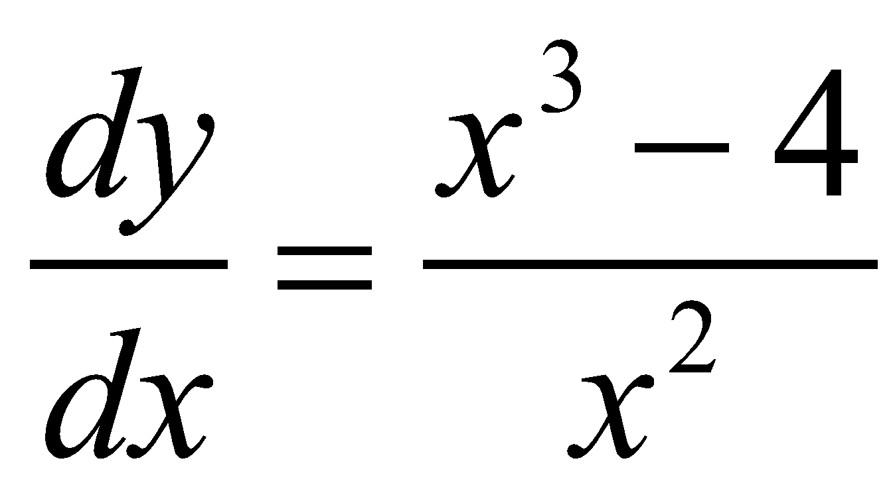 and y = 5 when x = 1.